INTEGRATIVE COURSE IN PSYCHOLOGY (ICOPSYCH)

ANALYSIS ON THE RESULT OF PRE-TEST EXAMINATION IN ABNORMAL PSYCHOLOGY
APRIL 26, 2025

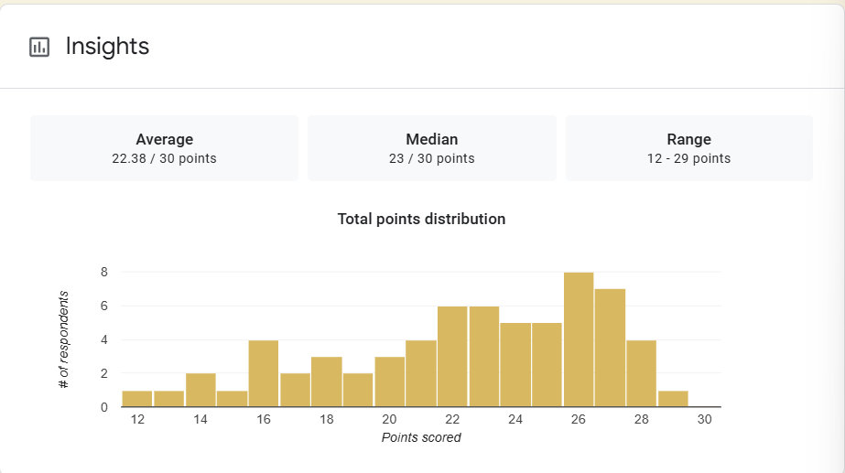

1. Mean Score: 22.38/30 points. This is the average score across all test takers. A mean of 22.38 out of 30 suggests that, overall, students performed fairly well, achieving about 75% of the total possible points.

2. Median Score: 23/30 points. The median is the middle score, meaning that half of the students scored above 23 and half scored below. The fact that the median is slightly higher than the mean suggests a slight left skew in the distribution; a few lower scores may be pulling the average down.

3. Range: 12–29 points. The difference between the highest and lowest scores is 17 points, indicating a moderate to wide variability in student performance. Some students performed very well (29), while others struggled significantly (as low as 12).

Interpretation Summary:

-The group did fairly well overall, with an average score around 75%.

-Slightly skewed to the left, suggesting a few lower scores are impacting the average.

-There is a noticeable range in ability or understanding among the students, pointing to potential gaps in learning or differences in preparation.

RATIONALIZATION:

DIFFICULT QUESTIONS:

